MoveGo

Julian Fernando Quiroz Farfan
Ariadna Cardona Martínez
Samuel Antonio Tarazona Fonseca

Universidad Manuela Beltrán
Ingeniería de Software
Carlos Eduardo Mujica Reyes
9 de marzo del 2025
Preguntas orientadas

- It refers to the structures of a system composed of elements with externally visible properties and relations between them. This definition is:
1. UML
2. Software Architecture
3. View
4. Controller
- It is a technical leader must know the principles related to software architecture, have extensive knowledge about technology and have excellent skills in written and oral communication. The previous profile refers to:
1. developer
2. Software architect
3. Tester
4. Analyst

Actividad de trabajo autónomo
Read the article called “The impact of Use Cases in real-world software development projects: A systematic mapping study” available in SCIENCEDIRECT DataBase and
formulate a concept map to summarize its content.
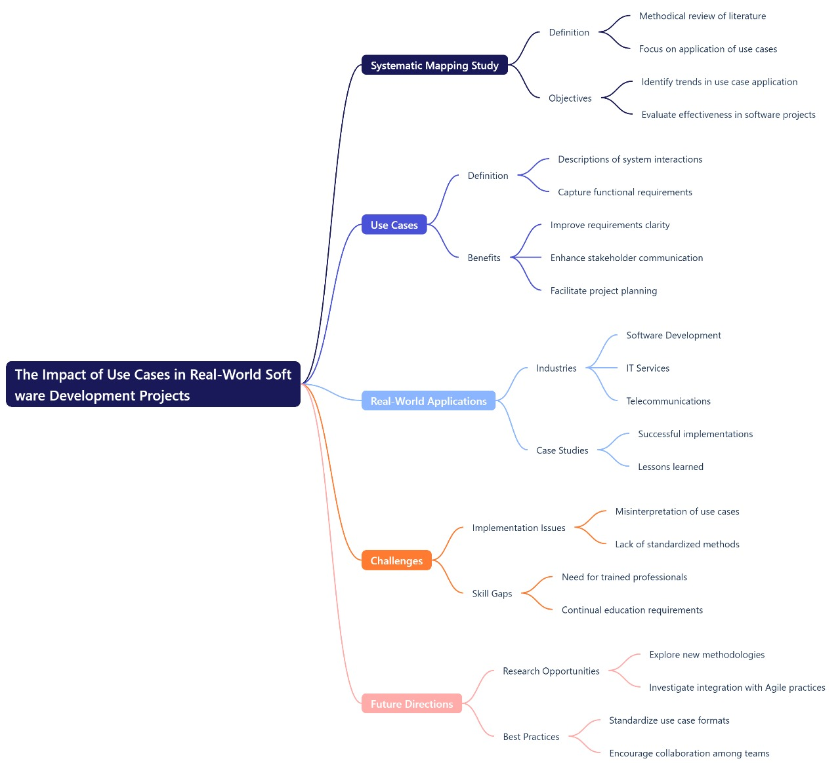

Procedimiento y metodología de la práctica
Sprint 1 Planning. Remember that tasks must be individual.
1. Build the product backlog. Remember that the product backlog should be prioritized (You must use 2 ways to prioritize).
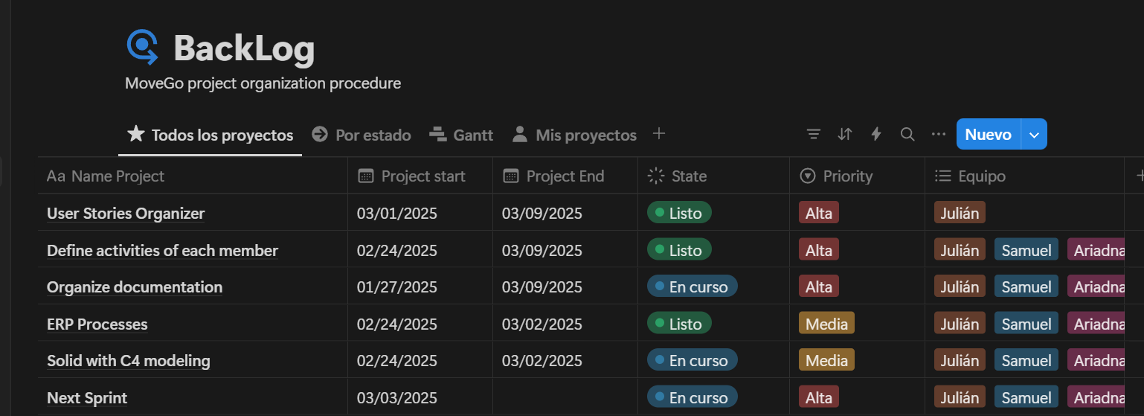
Link: https://special-moon-14a.notion.site/1b10c58163eb80f9a0b0e4cd8e3df2ad?v=1b10c58163eb803198e1000c93dd5dc4
2. Determine the "Definition of Done" established by the group for the development
of the project.
Definition of Done for MoveGo
The "Definition of Done" establishes the criteria that a user story must meet to be considered complete and ready for delivery in the MoveGo project.
- Complete Development
  - The code is developed, reviewed, and meets the user story requirements.
  - SOLID principles and defined design patterns have been applied.
- Unit and Functional Testing
  - Unit tests have been implemented with over 80% coverage.
  - Manual and automated functional tests have been conducted.
- Peer Review
  - The code has been reviewed by at least one team member.
  - Errors have been corrected, and implementations have been optimized based on received feedback.
- Integration and Deployment
  - The functionality is integrated into the main repository without conflicts.
  - It has been tested in a staging environment before deployment to production.
- Complete Documentation
  - Technical and user documentation has been updated.
  - Clear comments have been added to the code.
- Client Validation
  - Stakeholders have validated that the functionality meets their expectations.
  - Acceptance tests have been conducted to verify that the user story meets the defined criteria.
3. Build the Sprint Backlog for the first Sprint. For this:
a. Make a detailed specification of the stories selected for the sprint.
b. Prioritize those user stories with the greatest value to the end user.
c. Include at least 5 acceptance criteria for each story.
d. Determine the tasks needed to complete the stories proposed for the sprint.
Link:
https://www.notion.so/1b20c58163eb80709069cc0a607ca424?v=1b20c58163eb8006a248000cb254de48&pvs=4

4. Generate the effort estimate for each of the user stories according to their complexity. For this task it is suggested to use the planning poker strategy and allocate the weights using the Fibonacci series.
User stories were estimated using the Fibonacci sequence (1, 2, 3, 5, 8, 13, 21), where a higher value indicates greater complexity and effort required.

ID | User Story | Effort Points
HU01 | User Registration | 3
HU02 | Login and Authentication | 5
HU03 | Search for Available Vehicles | 5
HU04 | Vehicle Reservation | 8
HU05 | Payment Processing | 13
HU06 | Automatic Billing | 8
HU07 | Transaction History | 5
HU08 | Administrative Report Generation | 13
HU09 | Vehicle Inspection Report | 8
HU10 | Customer Support Chat | 8
HU11 | Loyalty Program and Discounts | 8
HU12 | Vehicle Return and Damage Reporting | 13

5. Sprint test planning. Test cases on selected platform (minimum 5 cases per HU)

HU01: User Registration
- Attempt to register with valid data → Successfully registered and receives confirmation email.
- Attempt to register with an existing email → System displays an error message.
- Enter a password that does not meet the requirements → System prevents registration.
- Leave a required field empty → System displays a warning and does not allow submission.
- Verify secure password storage → Password is stored encrypted.

HU02: Login and Authentication
- Log in with correct credentials → Successful login.
- Attempt to log in with an unregistered email → Error message is displayed.
- Attempt to log in with an incorrect password → System denies access.
- Test password recovery feature → Reset link is sent via email.
- Verify session persistence → Session remains active until manually logged out.

HU03: Search for Available Vehicles
- Search for a vehicle by name or model → Correct results are displayed.
- Search for a non-existent vehicle → "No results" message is shown.
- Apply a vehicle type filter → Only vehicles of the selected type are displayed.
- Sort results by ascending/descending price → Results are sorted correctly.
- Verify real-time search without reloading → Results update dynamically.

HU04: Vehicle Reservation
- Attempt to reserve an available vehicle → Reservation is confirmed.
- Attempt to reserve an unavailable vehicle → System prevents the action.
- Reserve more than one vehicle for the same dates → System displays a warning.
- Correctly calculate total cost based on dates → System applies accurate pricing.
- Verify reservation storage in the database → Data is saved correctly.

HU05: Payment Processing
- Pay with a valid card → Payment is successfully processed.
- Pay with an invalid card → System displays an error message.
- Retry a failed payment → User can attempt payment again.
- Verify payment security (encryption and tokenization) → Security measures are correctly applied.
- Generate and send payment receipt via email → Receipt is sent successfully.

HU06: Automatic Billing
- Generate an invoice after a successful payment → Invoice is correctly created.
- Attempt to generate an invoice without a payment → System prevents the action.
- Automatically send invoice via email → User receives the invoice.
- Download invoice in PDF format → Document is generated correctly.
- Store invoices in the system → Users can access them later.

HU07: Transaction History
- View history of reservations and payments → User’s transaction data is correctly displayed.
- Attempt to access history without logging in → System restricts access.
- Download history as a PDF → File is generated successfully.
- Filter transactions by date → Results match the applied filter.
- Verify transactions are listed in chronological order → Transactions are correctly sorted by date.

HU08: Administrative Report Generation
- Generate report on revenue and reservations → Data is correctly generated.
- Export reports in CSV and PDF formats → Files are successfully generated.
- Attempt to generate a report without admin permissions → System prevents the action.
- Apply date and transaction type filters → Reports reflect the filtered data.
- Verify real-time data updates → Reports display the latest available information.

HU09: Vehicle Inspection Report
- Complete an inspection report for a vehicle → Report is successfully saved.
- Attempt to submit an incomplete report → System displays an error message.
- Attach images to the inspection report → Images are uploaded correctly.
- Verify that only authorized users can submit reports → Unauthorized users are restricted.
- Generate a PDF report from an inspection → PDF is correctly created and downloadable.

HU10: Customer Support Chat
- Send a message through the support chat → Message is delivered successfully.
- Receive a response from an agent → Response appears in real-time.
- Attempt to send a message without logging in → System prevents the action.
- Test chatbot automated responses → Bot replies correctly based on user queries.
- Verify chat history storage → Users can view previous conversations.

HU11: Loyalty Program and Discounts
- Apply a valid discount code → Discount is successfully applied to the total price.
- Attempt to use an expired discount code → System rejects the code with an error message.
- Earn loyalty points after a completed rental → Points are correctly added to the user’s account.
- Redeem loyalty points for a discount → System applies the corresponding discount.
- Verify discount calculations in the final invoice → Discounted amount is correctly reflected.

HU12: Vehicle Return and Damage Reporting
- Return a vehicle and mark it as available → System updates vehicle status.
- Report a new damage upon vehicle return → System records the damage report.
- Upload photos of vehicle condition during return → Images are successfully saved.
- Verify penalty charges for reported damages → System calculates and applies extra charges correctly.
- Generate a final invoice including damage fees → Invoice reflects correct costs.
6. Identify the strengths and weaknesses of each team member. It is suggested to assign roles to lead technical, organizational, and quality aspects. These elements
are definitive in the success of the project and should be considered before starting
development. Complete the following table mentioning the strategies established
by the group in each case.

 | Strategies | In charge
Technical Aspects | - Define coding standards and best practices.  - Establish peer code reviews.  - Use version control tools (Git). | Julian
Communication | - Use daily meetings for Sprint follow-up.  - Centralize communication in Trello.  - Establish weekly reports of progress and roadblocks.  - Foster an environment of open communication and constant feedback. | Ariadna
Quality assurance | - Maintain clear and accessible technical documentation.  - Implement automated and manual tests.  - Perform usability and load tests before each delivery.  - Define clear acceptance criteria for each User Story. | Samuel

7. Propose a work schedule for the execution of the Sprint. Please note the following:
a. Integration and testing processes should be considered, as well as estimated completion dates for individual tasks.
b. Generate planning on Jira.
c. The estimated date for the completion of the Sprint is Friday from first exams week, but the presentation of the planning will be at march 5, so the sprint will have 2 weeks officially. The presentation on the increase of product (Sprint Review) will be made this day.
d. Progress in development must be evidenced through the project repository.
Progress reviews will be made on Fridays.
Link: https://special-moon-14a.notion.site/1b10c58163eb80f9a0b0e4cd8e3df2ad?v=1b10c58163eb803198e1000c93dd5dc4
8. All documentation related to design and planning should be available on Jira and on
the project page.
Diagrama Arc42
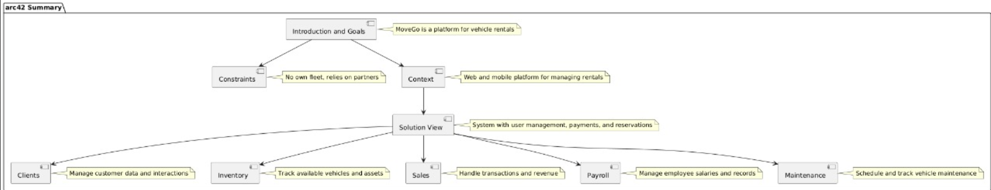

Link Presentación: https://www.canva.com/design/DAGhRRqBVLs/wR1aFdVLdDt7WnJv4_bwIQ/edit?utm_content=DAGhRRqBVLs&utm_campaign=designshare&utm_medium=link2&utm_source=sharebutton
Link Notion
https://special-moon-14a.notion.site/1b10c58163eb80f9a0b0e4cd8e3df2ad?v=1b10c58163eb803198e1000c93dd5dc4

